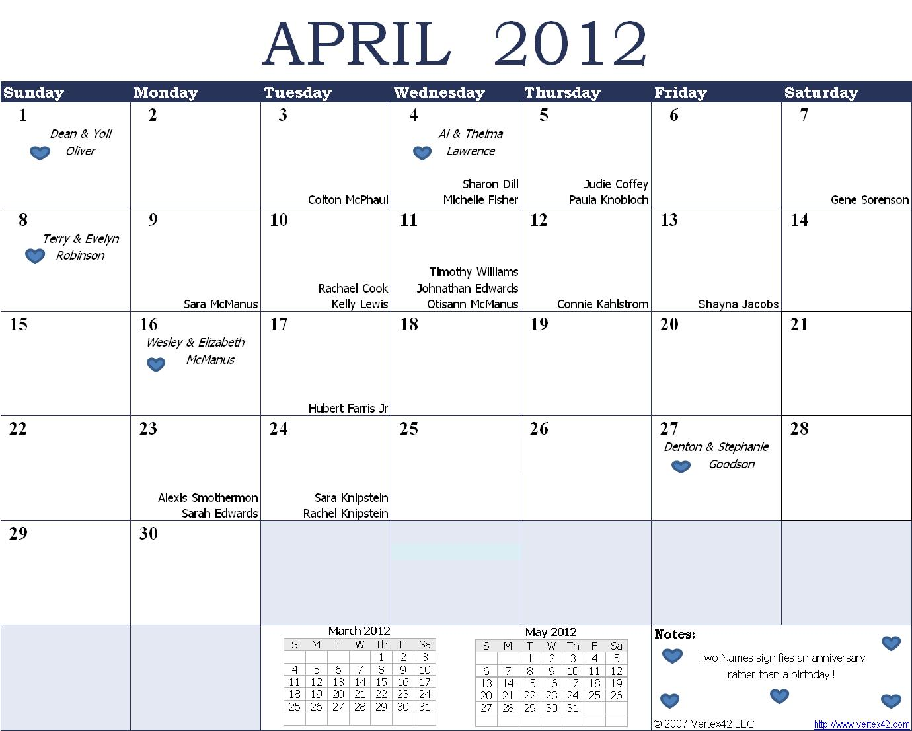

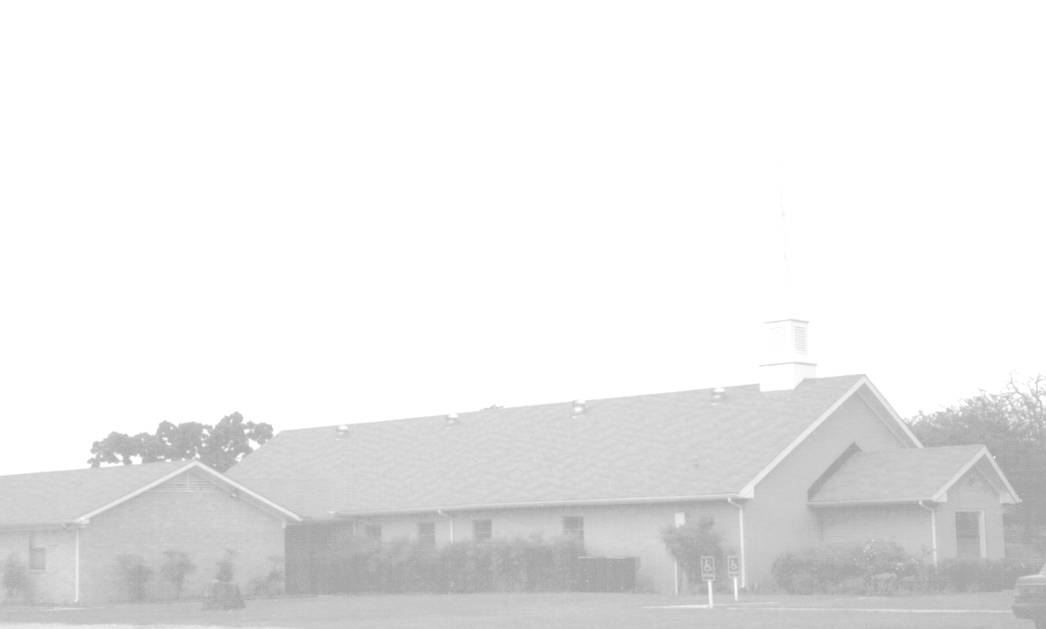
April Newsletter
151 YEARS of “Keep on Keeping On”
Knobbs Springs Baptist Church
1662 CR 305
McDade, TX 78650
Please email KnobbsSpringsBaptist@gmail.com to be removed from our mailing list. Thanks!


Non-Profit Organization
U. S. Postage Paid
Permit # 1
McDade, Texas

BAPTIST CHURCH

1662 CR 305

McDade, TX 78650

Phone: (512) 273-2743

Email: KnobbsSpringsBaptist@gmail.com

Pastor
Bro Mark McBride
(512) 229-6555
Txloves2fish@yahoo.com

Other Contacts
Cleyon Davis – Treasurer
(512) 856-2524

Kimberly Tabor – Office Manager
(512) 698-2804

April Ushers
Ray Edwards, Mike Turner
Daniel Davenport, Mickey Stanford

April Hostesses
Otisann McManus
Theresa Bartlett, Sheila Waggoner

April Nursery Schedule

1 0-2 Year Olds Angie Fisher
3-4 Year Olds Yoli Oliver
Helper

8 0-2 Year Olds Ashley Smothermon
3-4 Year Olds Otisann McManus
Helper

15 0-2 Year Olds Paula Hicks
3-4 Year Olds Tami Knipstein
Helper Jana Cashion

22 0-2 Year Olds Jana Moore
3-4 Year Olds Kristi Suchomel
Helper Anna McBride

29 0-2 Year Olds Karen Cotton
3-4 Year Olds Teresa Schane
Helper

Weekly Service & Activity Schedule:

SUNDAY
Sunday School 9:45 a.m.
Morning Worship Services 11:00 a.m.
Youth Activities 5:30 p.m.
Evening Services 7:00 p.m.

MONDAY
Zumba 6:30 p.m.

WEDNESDAY
Youth Worship 6:30 p.m.
Zumba 6:30 p.m.
Wednesday Services 7:00 p.m.

THURSDAY
Zumba 6:00 p.m.
Ladies Bible Study 6:30 p.m.

